Instructions for installing the Typing Program on your home PC

1. Insert the USB flash drive with the typing program on it into any available USB port
2. Open File Explorer. Then, navigate to the USB drive you inserted (it should show up as ‘ TYPING INST’ under ‘This PC’ in file explorer)
3. Double click on the file named ‘Install Python’.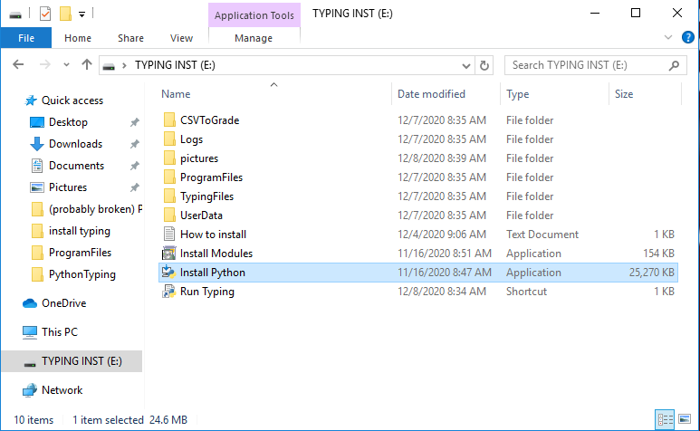
4. A Python Installer window will pop up. At the bottom of this window, check the box labeled ‘Add Python 3.7 to PATH’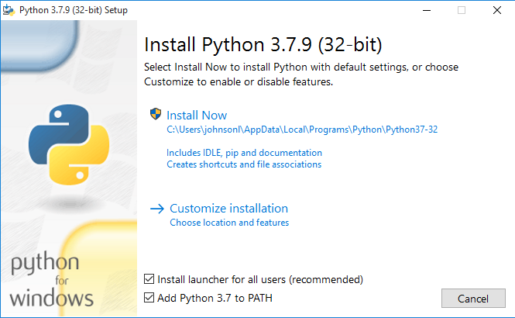
5. Next , select the option to Customize Installation
6. You will see a page called ‘Optional Features’. Do not change any of the default selections. Press the ‘Next’ button in the bottom right corner.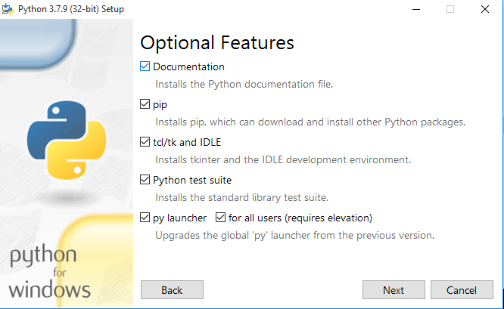
7. Next is the ‘Advanced Options’ page. On this page, check the ‘Install for all users’ box at the top of the list. Make sure the install location is ‘C:\Program Files (x86)\Python37-32’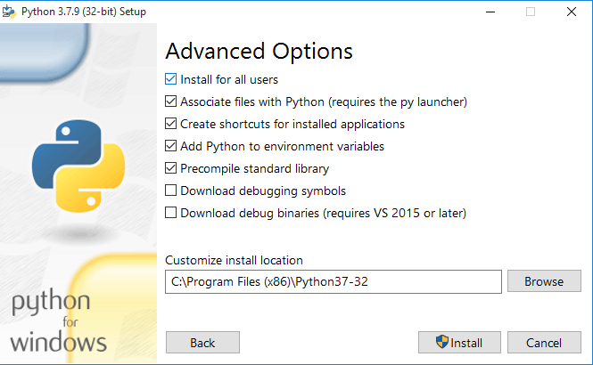
8. Now, click the ‘Install button in the bottom right hand corner. You will be prompted to give the installer permissions to install Python. Be sure to click yes, otherwise the installation will not work.
9. Be patient while the green progress bar reaches the end.
10. Close the installer window when this screen appears.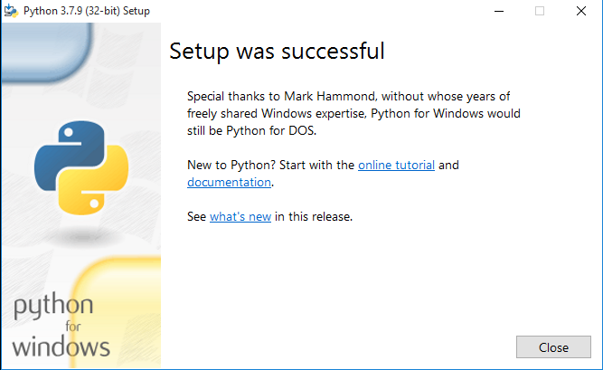
11. Go back to the USB drive in file explorer
12. Left – click once on the file named ‘Install Modules’.
13. You should see the Install Modules file highlighted in blue. Right – click on Install Modules.
14. After right – clicking on Install Modules, a small menu should appear. Click on ‘Run as administrator. When prompted, enter the administrator username and password for your computer if it asks for it. Otherwise, just click the ‘Yes’ button.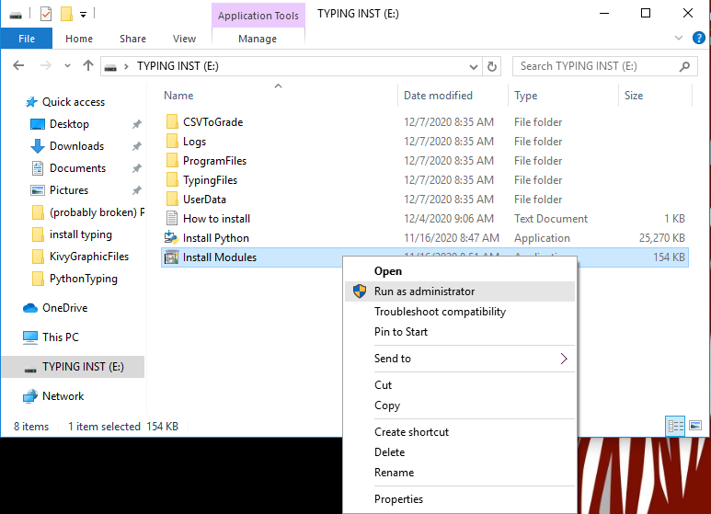
15. Wait for the pop-up window to close. Do not click anywhere on the pop up window while it is open, as this will stop the program from running properly.
16. Go back to the USB drive in file explorer.
17. Finally, double – click the ‘Run Typing’ shortcut.
18. You’re done! From now on, when you want to type, just go the USB drive in file explorer and double – click the ‘Run Typing’ shortcut.